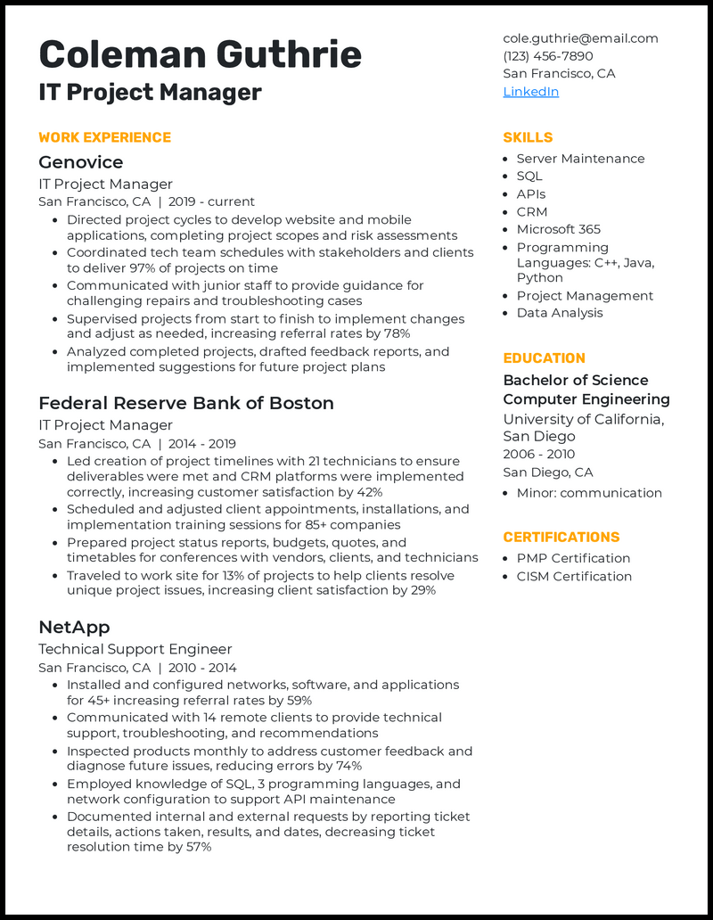
Coleman Guthrie
IT Project Manager
WORK EXPERIENCE
Genovice
IT Project Manager
San Francisco, CA | 2019 - current
• Directed project cycles to develop website and mobile applications, completing project scopes and risk assessments
• Coordinated tech team schedules with stakeholders and clients to deliver 97% of projects on time
• Communicated with junior staff to provide guidance for challenging repairs and troubleshooting cases
• Supervised projects from start to finish to implement changes and adjust as needed, increasing referral rates by 78%
• Analyzed completed projects, drafted feedback reports, and implemented suggestions for future project plans
Federal Reserve Bank of Boston
IT Project Manager
San Francisco, CA | 2014-2019
• Led creation of project timelines with 21 technicians to ensure deliverables were met and CRM platforms were implemented correctly, increasing customer satisfaction by 42%
• Scheduled and adjusted client appointments, installations, and implementation training sessions for 85+ companies
• Prepared project status reports, budgets, quotes, and
timetables for conferences with vendors, clients, and technicians • Traveled to work site for 13% of projects to help clients resolve unique project issues, increasing client satisfaction by 29%
NetApp
Technical Support Engineer
San Francisco, CA | 2010 - 2014
• Installed and configured networks, software, and applications for 45+ increasing referral rates by 59%
• Communicated with 14 remote clients to provide technical support, troubleshooting, and recommendations
• Inspected products monthly to address customer feedback and diagnose future issues, reducing errors by 74%
• Employed knowledge of SQL, 3 programming languages, and network configuration to support API maintenance
• Documented internal and external requests by reporting ticket details, actions taken, results, and dates, decreasing ticket resolution time by 57%
cole.guthrie@email.com
(123) 456-7890
San Francisco, CA LinkedIn
SKILLS
• Server Maintenance
• SQL
• APIs
• CRM
• Microsoft 365
• Programming Languages: C++, Java, Python
• Project Management • Data Analysis
EDUCATION
Bachelor of Science Computer Engineering University of California, San Diego 2006 - 2010 San Diego, CA
• Minor: communication
CERTIFICATIONS
• PMP Certification • CISM Certification

